Week 7 Homework Submission

**Task #1**

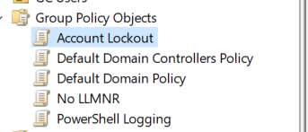

**Task #2**

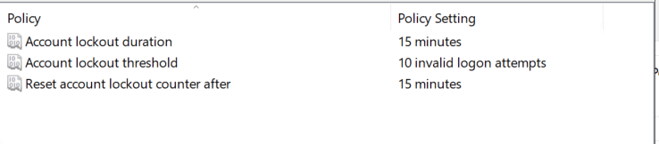

**Task #3**

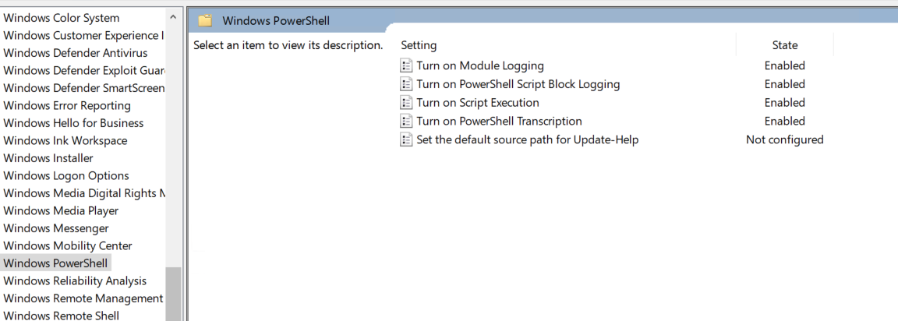

**Task #4**

Submit a copy of your enum_acls.ps1 script:

$directory=Get-childitem .\

foreach ($item in $directory) {

Get-Acl $item

}

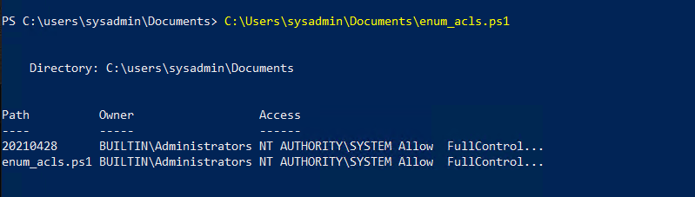

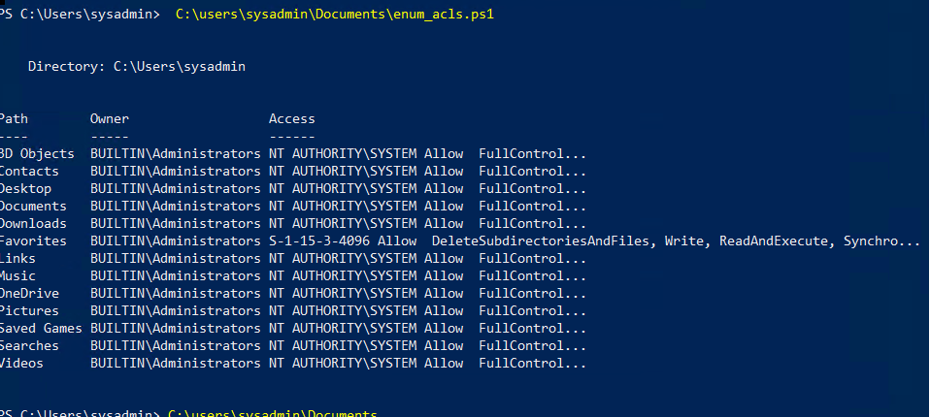

**Bonus**

